HashiCorp Infrastructure Automation Certification

Cloud engineers can use the Terraform Associate exam from HashiCorp to verify their basic infrastructure automation skills.

Prepare for the exam

Register for the exam

Certification Overview Certifications

HashiCorp Certified: Terraform Associate

The Terraform Associate certification is for Cloud Engineers specializing in operations, IT, or development who know the basic concepts and skills associated with open source HashiCorp Terraform. Candidates will be best prepared for this exam if they have professional experience using Terraform in production, but performing the exam objectives in a personal demo environment may also be sufficient. This person understands which enterprise

features exist and what can and cannot be done using the open source offering. Visit our exam partner to schedule and take the exam.

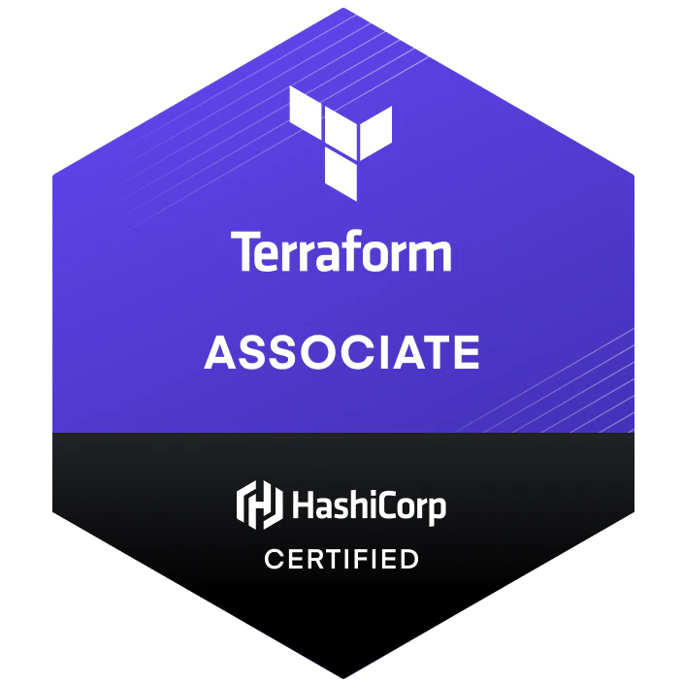

Prerequisites

Basic terminal skills
Basic understanding of on premises and cloud architecture

Product Version Tested

Terraform 0.14 and higher.

Preparing for the Exam

The Terraform Associate exam has both a study guide and a review guide. While much of the information in these two guides are the same, they are presented differently for different uses. Use the study guide if you want to study all the exam objectives. Use the review guide if you already have Terraform experience and want to choose which objectives to review

before taking the exam. We provide sample questions so you know what to expect when taking the exam.

Exam Details

Assessment Type | Multiple choice
Format | Online proctored
Duration | 1 hour
Price | $70.50 USD  plus locally applicable taxes and fees
Language | English
Expiration | 2 years

Exam Objectives

1 | Understand infrastructure as code (IaC) concepts
1a | Explain what IaC is
1b | Describe advantages of IaC patterns

2 | Understand Terraform's purpose (vs other IaC)
2a | Explain multi-cloud and provider-agnostic benefits
2b | Explain the benefits of state

3 | Understand Terraform basics
3a | Handle Terraform and provider installation and versioning
3b | Describe plugin based architecture
3c | Demonstrate using multiple providers

3d | Describe how Terraform finds and fetches providers
3e | Explain when to use and not use provisioners and when to use  local-exec or remote-exec

4 | Use the Terraform CLI (outside of core workflow)
4a | Given a scenario: choose when to use terraform fmt to format code
4b | Given a scenario: choose when to use terraform taint to taint Terraform resources
4c | Given a scenario: choose when to use terraform import to import existing infrastructure into your Terraform state
4d | Given a scenario: choose when to use terraform workspace to create workspaces
4e | Given a scenario: choose when to use terraform state to view Terraform state
4f | Given a scenario: choose when to enable verbose logging and what the outcome/value is

5 | Interact with Terraform modules
5a | Contrast module source options
5b | Interact with module inputs and outputs
5c | Describe variable scope within modules/child modules
5d | Discover modules from the public Terraform Module Registry
5e | Defining module version

6 | Navigate Terraform workflow
6a | Describe Terraform workflow ( Write -> Plan -> Create )

6b | Initialize a Terraform working directory ( terraform init )
6c | Validate a Terraform configuration ( terraform validate )

6d  6 | Generate and review an execution plan for Terraform ( terraform  Navigate Terraform workflow  plan )
6e | Execute changes to infrastructure with Terraform ( terraform apply )
6f | Destroy Terraform managed infrastructure ( terraform destroy )

7 | Implement and maintain state
7a | Describe default local backend
7b | Outline state locking
7c | Handle backend authentication methods
7d | Describe remote state storage mechanisms and supported standard backends
7e | Describe effect of Terraform refresh on state
7f | Describe backend block in configuration and best practices for partial configurations
7g | Understand secret management in state files

8 | Read, generate, and modify configuration
8a | Demonstrate use of variables and outputs
8b | Describe secure secret injection best practice
8c | Understand the use of collection and structural types
8d | Create and differentiate resource and data configuration

8e | Use resource addressing and resource parameters to connect resources together
8f | Use Terraform built-in functions to write configuration

88g | RCeoandfi,gguerneerreastoeu, arcned umsiondgifay cdoynnfaigmuircatibolnock
8h | Describe built-in dependency management (order of execution based)

9 | Understand Terraform Cloud and Enterprise capabilities
9a | Describe the benefits of Sentinel, registry, and workspaces
9b | Differentiate OSS and TFE workspaces
9c | Summarize features of Terraform Cloud

Business Email address

I agree to HashiCorp’s Privacy Policy.*

Subscribe to Newsletter



PROVISION

Multi-Cloud Infrastructure
SECURE

Multi-Cloud Security

CONNECT

Multi-Cloud Networking
RUN

Multi-Cloud Orchestration

PRODUCTS

Terraform Vault Consul Nomad Vagrant Packer Boundary Waypoint Sentinel
RESOURCES

Blog Tutorials Community Events Integrations Library Partners Podcast Support Training

COMPANY
About Us Jobs
Press Center Brand Contact Us

System Status Cookie Manager Terms of Use Security Privacy Trademark Policy
stdin: is not a tty

